Loop Programming Practice Lab
Part 1
70pts (10 points each): Take each of the loops programed here and give the equivalent loop asked for. Your submission through eCampus for the entire lab should be a single .cpp file.
1. Convert the following for loop into a do/while loop
for (int i = 6; i < 10; i++)
cout << i << " ";
cout << endl;

2. Convert the while loop into a for loop
int w = 35;
while (--w>0)
{
if (w > 5)
w -= 4;
cout << "T-" << w << ", ";
}
cout << "Lift-off" << endl;

3. Convert this do/while loop into a for loop
int loop = 10;
do{
cout << --loop << " ";
} while (loop > 5);
cout << endl;

4. Convert this for loop into a do/while loop
int j = 17;
for (int i = 0;i<j;)
{
cout << i << " ";
if (j-- % ++i == 0)
i += j / 2;
}
cout << endl;
5. Convert this for loop into a while loop
for (int i = 5, j = 8;;j++)
{
cout << i << ", ";
i += j % 4;
if (j < i)
break;
}
6. Convert this while loop into a for loop
int x = 18;
while (x)
{
if (x-- % 3)
continue;

cout << (x*x) << ", ";
}
7. Convert this for loop into a do/while loop
for (int y=39;;y++)
{
cout << y << ", ";
y += y % 8;
if (y > 90)
break;

}
Part 2 (30 points)
Output the following using nested loops
- For 10pts, output a Multiplication table. Be sure to output the row and column number and add decorations to set these labels apart from the rest of the table. setw may be useful here as well to make the table line up. (Remember that in order to use it you need to include iomanip.)

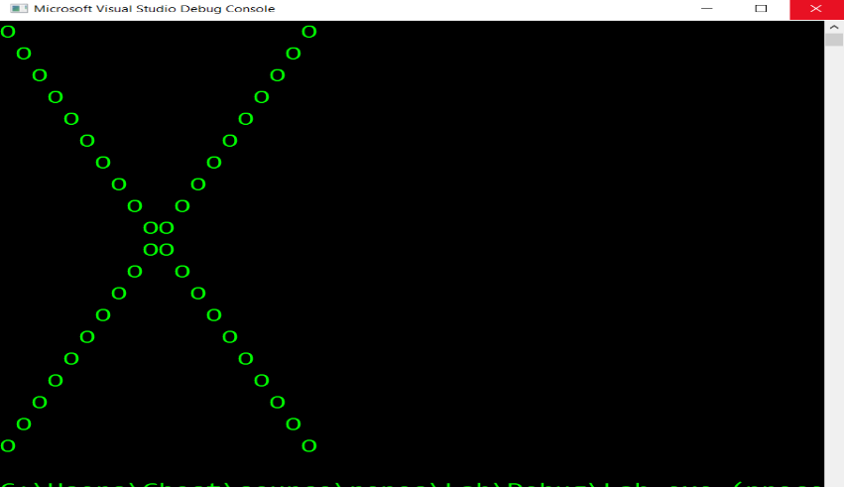
- For 10pts output a Diamond shape. You should start by drawing 1 triangle with dependent loops like shown in class (or in chapter 5). Make an inner loop that is dependent on the outer loop to get the pattern. Think carefully about when you can go down to the next line (where to add endl’s), and where you need to continue your loops.
- For 10pts, draw the x pattern shown here. As a hint, you can compare when the row variable (outer loop), matches the column variable (inner loop). Note that the green color is not part of the problem, it is just the default console output for my home machine.

Bonus: For 10pts additional points: If I’m going to have you make another diamond I’m going to want something more out of you. Can you control the output of the loops so that it draws a pattern starting with a slash on the outside, followed by a star, and then a plus sign (see below). The slash should be changed to match the direction and should always be on the outermost layer. Then the pattern should go from there (slash,star,plus…) until reaching the center. Make sure to base this one off of a variable size (could be read in through cin or set in code but the pattern should work even if the size changes)

Size 10:

Size = 17:

